Product Strategy Coaching Playbook

Purpose
The Product Strategy Coaching playbook, outlines the strategy process that the coaching platform will take Clients through. This holds for human and AI coaches within the platform.

The coaching platform will guide Enterprises (C-Suite, Product Model leadership and teams) through how to adopt a tailored Product Model and Product Strategy creation process. This will include systematic research and analysis to inform and provide insight on strategic positioning, product strategy and objectives, which connect the Company, Product and Team strategy to ensure alignment and focus on the highest Customer and Business outcomes.

This will be an evolving document which is iteratively improved as the platform evolves. It will take Client and coach feedback through continuous feedback loops. Any updates to the playbook must be revied and checked in through a version controlled process.

Playbook Principles

Process Architecture
Each phase of the Coaching platform and strategy development process will have five defined states:
- Principle: Our Foundational belief
- Process: The method we use to achieve the outcome
- Inputs: Which inputs are helpful, required to initiate the phase
- Artefact: The document that records the valuable learning and insights we have gathered through the process
- Outcome: What we have learned and decided that informs the next stage

There will be personalisation and adaptability within elements of this dependant on the Enterprise and Clients needs. However each phase will require these 4 states to be defined and completed for the coaching process to operate.

Product Strategy Process Outline
The Product Strategy will follow X core phases

Product Model Principles
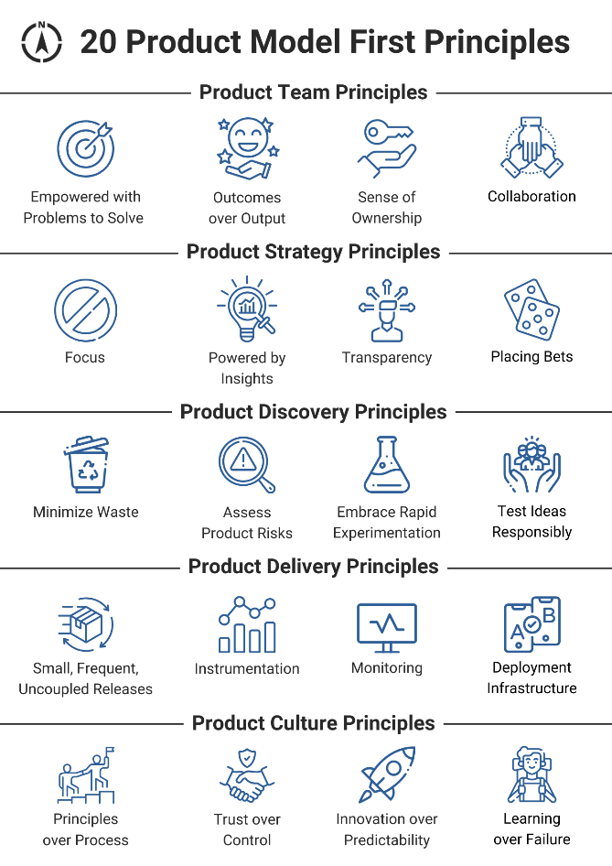

Product Team Risks
In the Product Model Product Teams are made up of a minimum a Product Manager, Product Design and set of Engineers. They may require other skillsets such as dedicated Data Engineer, but the above is the minimum standard.

They collectively are empowered to own a Product or Customer Journey, with a key set of Customer problems to solve. These Customer problems and target outcomes are driven from the Product Strategy.

Product Teams Principles
Empowered with Customer Problems to Solve. This means the teams are empowered to define how they solve the Customer outcomes, through their cross functional skills, deep collaboration and Customer Discovery.

Targeted to Deliver Outcomes over Outputs. Outcomes are framed as objectives which define the target state/ feeling a Customer wants to achieve/ receive as a service and the outcome is measured through quantifiable changes in human behaviour from Customers.

